

The Commission for the Conservation and Management of
Highly Migratory Fish Stocks in the Western and Central Pacific Ocean

Scientific Committee

North Pacific Shortfin Mako Shark (Isurus oxyrinchus)

Stock Status and Management Advice

Contents
SC15 2019 (NO STOCK ASSESSMENT) 2
SC14 2018 (STOCK ASSESSMENT CONDUCTED) 2
Useful References 5
PREVIOUS ASSESSMENTS 5

SC15 2019 (NO STOCK ASSESSMENT)

- Stock status and trends

- SC15 noted that no stock assessments were conducted for North Pacific shortfin mako shark in 2019. Therefore, the stock status descriptions from SC14 are still current for North Pacific shortfin mako shark. For further information on the stock status and trends from SC14, please see https://www.wcpfc.int/node/32155. Updated information on catches was not compiled for and reviewed by SC15.

- Management advice and implications

- SC15 noted that no management advice has been provided since SC14 for North Pacific shortfin mako shark. Therefore, previous advice should be maintained, pending a new assessment or other new information. For further information on the management advice and implications from SC14, please see https://www.wcpfc.int/node/32155.

SC14 2018 (STOCK ASSESSMENT CONDUCTED)

- Stock status and trends

- SC14 noted that ISC provided the following conclusions on the stock status of North Pacific Shortfin Mako Shark in the Pacific Ocean in 2017, as presented in SC14-SA-WP-11 (Stock Assessment of Shortfin Mako Shark in the North Pacific Ocean Through 2016).

Based on these findings, the following information on the status of the SFM stock is provided:
- Target and limit reference points have not been established for pelagic sharks in the Pacific Ocean. Stock status is reported in relation to MSY.
- The results from the base case model show that, relative to MSY, the North Pacific shortfin mako stock is likely (>50%) not in an overfished condition and overfishing is likely (>50%) not occurring relative to MSY-based abundance and fishing intensity reference points (Table SFM-4; Figure SFM-9A).

Stock status was also examined under six alternative states of nature that represented the most important sources of uncertainty in the assessment. Results of these models with alternative states of nature were consistent with the base case model and showed that, relative to MSY, the North Pacific shortfin mako shark stock is likely (>50%) not in an overfished condition and overfishing is likely (>50%) not occurring (Figure SFM-9B).

- Management Advice and implications

- SC14 noted the following conservation advice from ISC:

Stock projections of biomass and catch of North Pacific shortfin mako from 2017 to 2026 were performed assuming three alternative constant fishing mortality scenarios: 1) status quo, average of 2013-2015 (F₂₀₁₃-₂₀₁₅); 2) F₂₀₁₃₋₂₀₁₅ + 20%; and 3) F₂₀₁₃₋₂₀₁₅ - 20% (Figure SFM-10).

Based on these future projections, the following conservation information is provided:
- If fishing mortality remains constant at F2013-15 or is decreased 20%, then the Stock Abundance is expected to increase gradually;
- If fishing mortality is increased 20% relative to F2013-2015, then the Stock Abundance is expected to decrease in the final years of the projection.
- It should be noted that, given the uncertainty in fishery data and key biological processes within the model, especially the stock recruitment relationship, the models’ ability to project into the future is highly uncertain.

Research Needs

There is uncertainty in the estimated historical catches of North Pacific shortfin mako shark. Substantial time and effort was spent on estimating historical catch and more work remains to be conducted. In particular, the SHARKWG identified two future improvements that are critical: 1) identify all fisheries that catch shortfin mako shark in the NPO, including fisheries that were not previously identified by the SHARKWG; and 2) methods to estimate shortfin mako shark catches should be improved, especially for the early period from 1975 to 1993.

Table SFM-4. Summary of reference points and management quantities for the shortfin mako shark (Isurus oxyrinchus) base case model. The percentages in brackets are the CV of the estimated quantity in the base case model.
Management Quantity | Symbol | Units | Base case
Spawning abundance (number of mature female sharks | SA0 | 1000s of sharks | 1465.8 (23%)
Maximum Sustainable Yield (MSY) | CMSY | Metric tons (t) | 3127.1 (22%)
Spawning Abundance at MSY | SAMSY | 1000s of sharks | 633.7 (23%)
Fishing Intensity at MSY | 1-SPRMSY | NA | 0.26
Current spawning abundance relative to MSY | SA2016/SAMSY | NA | 1.36
Current spawning abundance relative to unfished level | SA2016/SA0 | NA | 0.58
Recent fishing Intensity relative to MSY | (1-SPR2013-15)/(1- SPRMSY) | MSY | 0.62

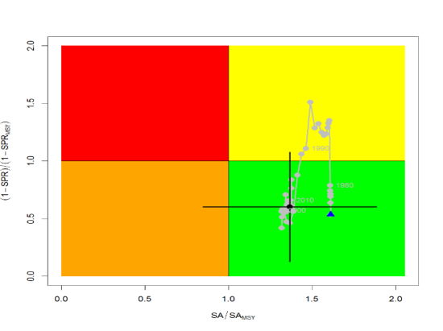
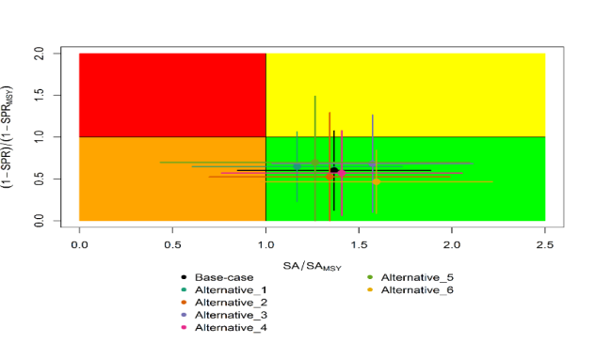
A
B
Figure SFM-9. Kobe plots of shortfin mako shark in the North Pacific Ocean showing. A) The time series of the ratio of SA to SA at MSY (SA_{MSY}) and fishing intensity to fishing intensity at MSY (1-SPR_{MSY}), and B) the same ratios for the terminal year (2016) for six alternative states of nature. SA is spawning abundance measured as the number of mature females. Fishing intensity is estimated as 1-SPR. Values for the start (1975) and end (2016) years in the time series (A) are indicated by the blue triangle and black circle, respectively. Gray numbers indicate selected years. Alternative states of nature in B) include: Alternative_1) higher catch, Alternative_2) lower catch; Alternative_3) higher uncertainty on Japan shallow-set CPUE index (1975-1993) (CV=0.3); Alternative_4) fit to Japan offshore distant water longline shallow-set fleet (JPN_SS_I; 1975-2016) and Hawaii longline shallow-set fleet (US_SS; 2005-2016), and no fit to initial equilibrium catch; Alternative_5) low steepness, h=0.26; and Alternative_6) high steepness, h=0.37. Solid lines indicate 95% confidence intervals.

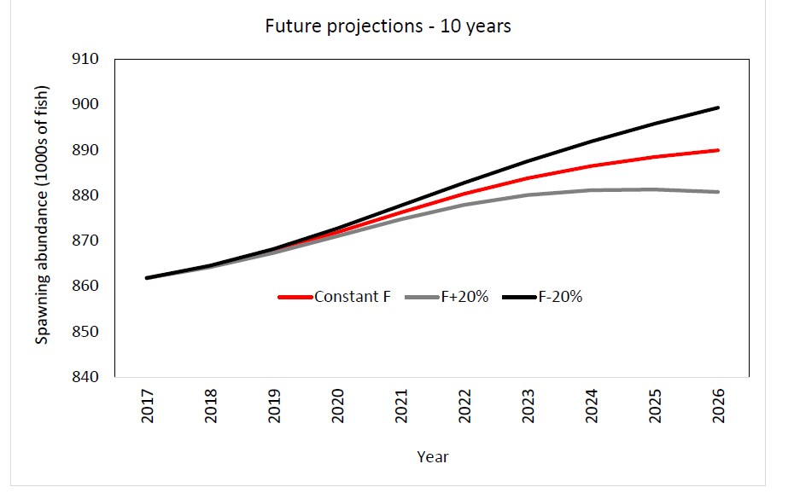
Figure SFM-10. Comparison of future projected North Pacific shortfin mako (Isurus oxyrinchus) spawning abundance under different F harvest policies (Constant F 2013-2015, +20%, -20%) using the base case model. Constant F was based on the average from 2013-2015.

Useful References

SC14-SA-WP-11 Stock Assessment of Shortfin Mako Shark in the North Pacific Ocean Through 2016. https://www.wcpfc.int/node/31025

For current information related to Northern Stocks Working Group Reports and the ISC Plenary Report:
http://isc.fra.go.jp/reports/isc/isc18_reports.html

PREVIOUS ASSESSMENTS
SC11-SA-WP-08 Indicator-based analysis of the status of shortfin mako shark in the North Pacific ocean. https://www.wcpfc.int/node/21778

